Narrative characterization: actors, factors, and mechanisms

When characterizing a narrative in terms of actor, factor, and mechanism (AFM) involves identifying the main participants (actor), the contributing elements or circumstances (factors), and the processes or actions taken (mechanisms). In the context of a knowledge graph, the nodes represent actors, factors, and mechanisms. At the same time, the edges show the relationships on how actors use mechanisms to interact with factors (actions taken by actors), such as “upheld the redistricting,” “criticized the decision,” and “benefited from redistricting.” Actors can range from governmental bodies to grassroots movements, each playing a distinct role in the narrative construction. Factors encompass the various elements influencing the narrative, such as values, interests, and divergences among stakeholders. Conversely, mechanisms delve into the actors’ actions, strategies, and processes to advance their narratives and agendas. By mapping out these components in a knowledge graph, one can visualize the intricate web of relationships and connections that underpin the storytelling in politics and policymaking.

For instance, we have the following narrative:

*President Joe Bide criticized the Supreme Court’s decision on the redistricting of the South Carolina district by issuing a public statement highlighting concerns about racial discrimination.* To identify what the AFMs are from the text, it could be: “**President Joe Biden** (actor) criticized the **Supreme Court's decision** (factor) on the **redistricting of the South Carolina district** (factor) by issuing a **public statement** (mechanism), highlighting concerns about **racial discrimination** (factor).”

To identify the AFMs from the narrative, large language models (LLMs) can be used for extraction. The advance of LLMs has enabled the automatization of this process. By prompting the LLM (gpt-4o), we can obtain: 1) the characterization of the narrative and 2) extract the nodes and edges for the visualization.

# Narrative characterization

**System:** You are a helpful assistant who characterizes narratives into actors, factors, and mechanisms. Actors can range from governmental bodies to grassroots movements, each playing a distinct role in the narrative construction. Factors encompass socioeconomic, cultural, and environmental variables, while mechanisms refer to processes or actions taken to generate events, analyze a text, and extract the actors, factors, and mechanisms.

**Prompt:** What are the actors, factors, and mechanisms in the following text

Text: President Joe Biden criticized the Supreme Court’s decision on the redistricting of the South Carolina district by issuing a public statement highlighting concerns about racial discrimination.

|  |  |  |  |
| --- | --- | --- | --- |
| **Type/LLMs** | **gpt-4o** | **llama3** | **mistral** |
| **Actors** | 1. **President Joe Biden** - The individual who issued the public statement. 2. **Supreme Court** - The judicial body that made the decision on the redistricting of the South Carolina district. | 1. President Joe Biden 2. The Supreme Court | 1. President Joe Biden - The individual who issued the public statement regarding the Supreme Court's decision on redistricting in South Carolina. 2. The Supreme Court - The judicial body that made the decision on redistricting in South Carolina. 3. The people of South Carolina - Indirectly, as they are affected by the redistricting decision. |
| **Factors** | 1. **Redistricting of the South Carolina district** - The specific action or decision made by the Supreme Court that is being criticized. 2. **Racial discrimination** - The concern highlighted by President Biden in his criticism of the Supreme Court's decision. | 1. Racial discrimination 2. Redistricting (redrawing of electoral district boundaries) 3. Political concerns | 1. Redistricting - The process of dividing a region into electoral districts to reflect changes in population. 2. Racial Discrimination - The practice of treating different racial groups unfairly, which is a concern raised by President Biden in this context. 3. Political Boundaries - The geographical boundaries within which political representation occurs. 4. Constitutional Laws and Regulations - The laws and regulations that govern the process of redistricting, including those related to prohibiting racial discrimination. |
| **Mechanisms** | 1. **Issuing a public statement** - The method used by President Biden to express his criticism and highlight his concerns about the Supreme Court's decision. | 1. Public statement (a formal declaration or announcement made by President Biden) | 1. Public Statement - A means by which President Biden expressed his concerns about the Supreme Court's decision on redistricting in South Carolina, addressing the issue publicly. 2. Judicial Review - The power held by the Supreme Court to review and potentially overturn laws or decisions made by other branches of government (in this case, the legislature responsible for drawing district boundaries). 3. Legal Challenge - If President Biden's concerns about racial discrimination are substantiated, it could lead to a legal challenge against the redistricting decision. 4. Media Dissemination - The process by which the public becomes aware of President Biden's statement and the Supreme Court's decision on redistricting, as well as any subsequent developments or responses. |

# Extract nodes and edges for the visualization

Prompt: Make a visual representation of the narrative characterization. Consider that the nodes represent actors, factors, and mechanisms in the context of a knowledge graph. At the same time, the edges show the relationships on how actors use mechanisms to interact with factors (actions taken by actors), such as “upheld the redistricting,” “criticized the decision,” and “benefited from redistricting.”

**Output:** Here is the visual representation of the narrative characterization as a knowledge graph. The nodes represent actors, factors, and mechanisms, while the edges show the relationships and how actors use mechanisms to interact with factors. The colors differentiate between actors (skyblue), factors (lightgreen), and mechanisms (lightcoral).

* **Actors**:
  + President Joe Biden
  + Supreme Court
  + South Carolina district
* **Factors**:
  + Racial Discrimination
  + Values and Interests
  + Divergences among Stakeholders
* **Mechanisms**:
  + Public Statement
  + Highlighting Concerns
  + Criticism
* **Relationships**:
  + President Joe Biden uses a Public Statement to highlight Racial Discrimination.
  + President Joe Biden uses Highlighting Concerns to bring attention to Racial Discrimination.
  + President Joe Biden uses Criticism to challenge the Supreme Court.
  + The Supreme Court influences Values and Interests.
  + The South Carolina district is affected by Racial Discrimination.
  + The Supreme Court creates Divergences among Stakeholders.

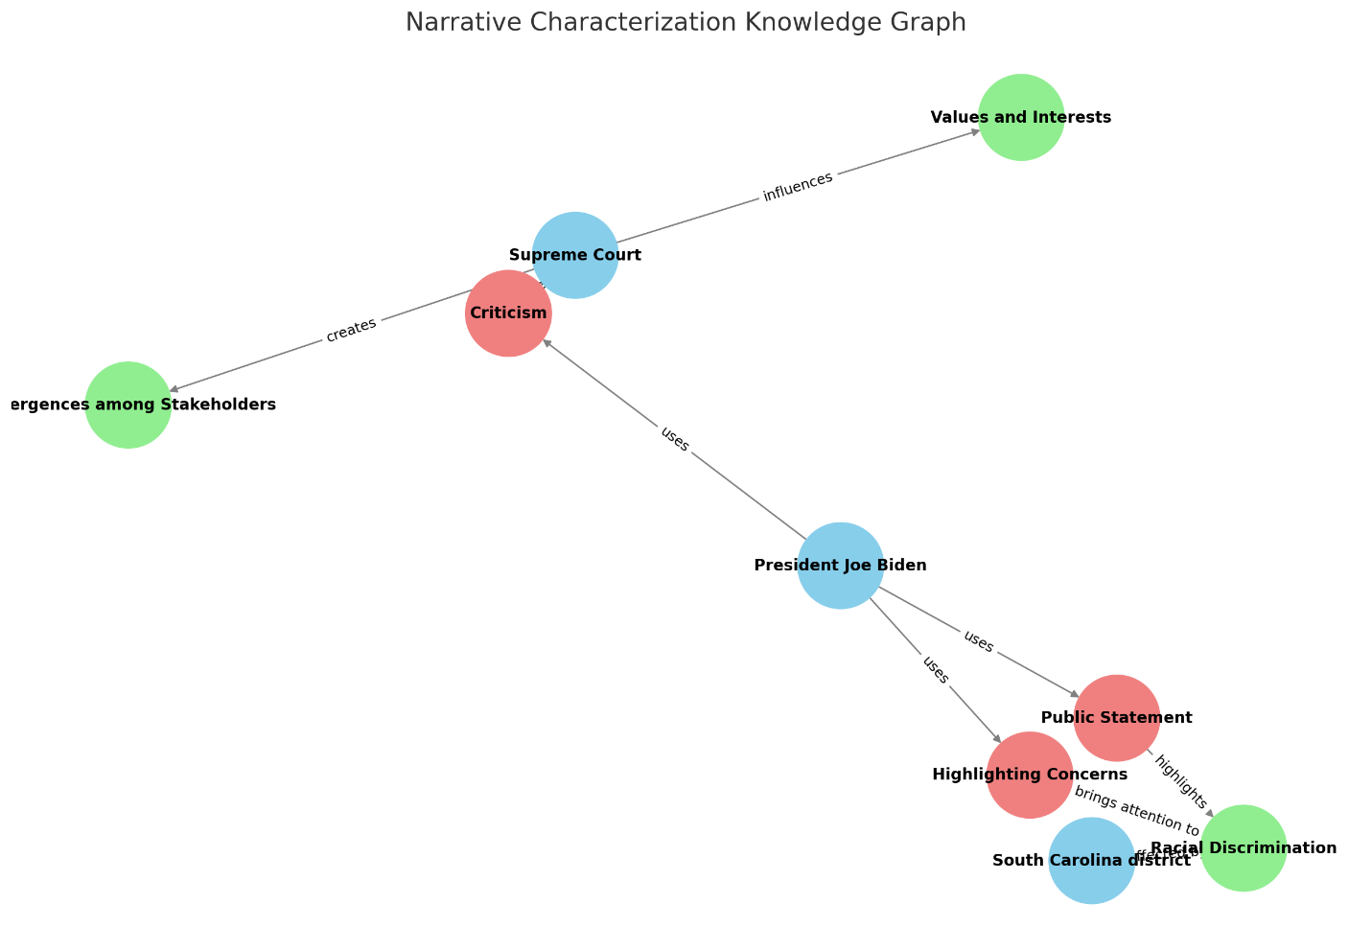

Figure 1. AFM Visual representation of the narrative

# ABM Characterization

We use the same test case of Padilla et al. (2019), a description of the role of elites in social norm diffusion from Salimi et al. (2019), which was used to identify agents, agent attributes, and rules using the analyzer. The paper has an ABM implementation, which we used for verification purposes. The following is the description provided by the lead author:

*Advocates are not always socially positioned to be effective norm promoters on their own. For this reason, they rely on elites in a society who have large networks and strong influence over others such as celebrities and politicians. By convincing elites to adopt norms, advocates increase their ability to reach a wider public audience. It should be noted that advocates promote a norm based on a logic of appropriateness, while elites advertise a norm based on the logic of consequences. In other words, advocates are often not assessing the utilities or benefits of the norm and will never change their mind about that norm; they are like zealots about the norm. Elites, on the other hand, assess the utilities and benefits of norm adoption relative to their level of social power. Iglič and Rus suggest that less powerful, new elites may be targets of norm promoters/advocates because they see the new norm as a potential tool to maximize their utility and balance power against more powerful, old elites. While advocates my use international organizations or nongovernmental organizations to convince elites to adopt norms, and social media also plays a significant role in this process, the current version of the model does not account for these specific means of convincing elites. The tipping point in the norm life cycle is reached when the balance of power between opponent and proponent of the new norm has shifted. At that point, the new norm will begin to be substituted for the existing norm, or it will become the dominant norm. When the norm’s life cycle reaches the tipping point, it means the dominant norm is the new norm and a considerable percent of the population supports that norm. After this point, the spread of the norm will reach a higher speed compared to the previous step, and many people from different groups of society may adopt the norm. Norm cascading for humanitarian norms may be different from other norms because degradation of humanitarian values has a diverse and exponential relation to the percent of advocates and therefore is a limiting factor in this process of cascading. This denotes a key difference in norms that have associated punishments, which would prevent individuals from losing interest in a norm over time and delaying the cascade process of norm adoption. During the cascade phase of norm adoption, elites must socialize a norm to persuade others to adopt. Since individuals’ motivation to adopt a new norm is based on the logic of consequences—assessing the costs and benefits of adoption for each new norm—it is impossible for elites to socialize norms and persuade others who have no desire to be a part of that social group. Again, this is an important distinction between norms that are adopted through punishment mechanisms. In fact, peer pressure may be regarded as a form a social punishment by which certain norms are socialized to others and individuals find that socially the benefits of adoption outweigh the costs.*

**System:** You are a helpful assistant who characterizes narratives into actors, factors, and mechanisms. Actors can range from governmental bodies to grassroots movements, each playing a distinct role in the narrative construction. Factors encompass socioeconomic, cultural, and environmental variables, while mechanisms refer to processes or actions taken to generate events, analyze a text, and extract the actors, factors, and mechanisms.

**Prompt:** What are the actors, factors, and mechanisms in the following text

|  |  |  |  |
| --- | --- | --- | --- |
| **Type/LLMs** | **GPT-4o** | **Llama3** | **Mistral** |
| **Actors** | 1. Advocates 2. Elites 3. Less Powerful/New Elites 4. International Organizations and NGOs 5. General Public | 1. Advocates 2. Elites (e.g., celebrities, politicians) 3. International Organizations 4. NGOs 5. Social Media Users 6. Opponents of a New Norm 7. Proponents of a New Norm | 1. Advocates 2. Elites (e.g., celebrities, politicians, less powerful new elites) 3. International Organizations 4. NGOs 5. Population at Large 6. Old Elites |
| **Factors** | 1. Social Positioning of Advocates 2. Logic of Appropriateness vs. Logic of Consequences 3. Balance of Power 4. Humanitarian Norms 5. Social Punishment and Peer Pressure | 1. Logic of Appropriateness 2. Logic of Consequences 3. Social Power 4. Utility and Benefits of Norm Adoption 5. Norm Life Cycle 6. Percent of Advocates Supporting a New Norm 7. Degradation of Humanitarian Values | 1. Logic of Appropriateness 2. Logic of Consequences 3. Social Power 4. Utility 5. Costs and Benefits of Norm Adoption 6. Peer Pressure 7. Punishment Mechanisms |
| **Mechanisms** | 1. Convincing Elites 2. Norm Life Cycle 3. Norm Cascading 4. Socialization by Elites 5. Assessment of Costs and Benefits 6. Punishment Mechanisms | 1. Convincing Elites to Adopt Norms 2. Using International Organizations or NGOs 3. Utilizing Social Media 4. Socialization of Norms by Elites 5. Peer Pressure 6. Norm Cascading | 1. Convincing Elites to Adopt Norms 2. Socialization of a Norm 3. Norm Cascading 4. Tipping Point in the Norm Life Cycle 5. Degradation of Humanitarian Values |

# Reference

Padilla, J. J., Shuttleworth, D., & O’Brien, K. (2019). Agent-Based Model Characterization Using Natural Language Processing | IEEE Conference Publication | IEEE Xplore. *2019 Winter Simulation Conference (WSC)*. <https://doi.org/10.1109/WSC40007.2019.9004895>

Salimi, K., Frydenlund, E., Padilla, J. J., Haaland, H., & Wallevik, H. (2019). The Role Of Elites In The Diffusion Of Social Norms Of Humanitarianism | IEEE Conference Publication | IEEE Xplore. *2019 Spring Simulation Conference (SpringSim)*. <https://doi.org/10.23919/SpringSim.2019.8732925>